Minutes Of City Council
City Of Sargent, Nebraska
Regular Session
Sargent Community Center
June 11, 2024

The Mayor and Council of the City of Sargent, Nebraska, met in Regular Session at the Sargent Community Center on the 11th day of June, at 7:00 p.m. Notice of the meeting was posted at the City Office, U. S. Post Office, Sargent Corner Market and First National Bank on Tuesday June 4, 2024. The following were present: Council Members: Micky Schneider, Tim Clayton, Ricky Hightower, and Mayor Myers, Troy Gavin, City Administrator, and City Clerk/Treasurer Gwenda Horky.

Mayor Myers stated a current copy of the Nebraska Open Meetings Act was available for review and indicated the location of such copy posted on the east wall of the meeting room in the Sargent Community Center. Mayor Myers called the meeting to order at 7:00 p.m.

Council Member Clayton moved to approve the consent agenda. Council Member Hightower seconded. Voting yea: Schneider, Hightower, and Clayton. Voting nay: None. Motion carried

Council Member Clayton moved to approve the building permit for Earl and Kathy Drake at 304 W Jessie for a fence and shed. Council Member Hightower seconded. Voting yea: Hightower, Schneider, and Clayton, Voting nay: None. Motion carried.

Council Member Schneider moved to approve the Church of Christ building permit at 200 S 2nd street for a building. Council Member Clayton seconded. Voting yea: Hightower, Schneider, and Clayton. Voting nay: None.

Council Member Schneider moved to approve the Disaster Grant payments of $20,925.00 Council Member Clayton seconded. Voting yea: Clayton, Schnieder and Hightower. Voting nay: None. Motion carried.

Council Member Schneider moved to approve the interlocal agreement with Custer County for the Airport. Council Member Clayton seconded. Voting yea: Hightower, Schneider, and Clayton. Voting Nay: None. Motion carried

Council Member Schneider moved to approve a letter of intent for a Rural Development Grant of one million dollars for the swimming pool. Council Member Hightower seconded. Voting yea: Hightower, Clayton, and Schneider. Voting nay: None. Motion carried.

Kevin Gustafson sent the Council a report on the Sargent Flood Resiliency Project

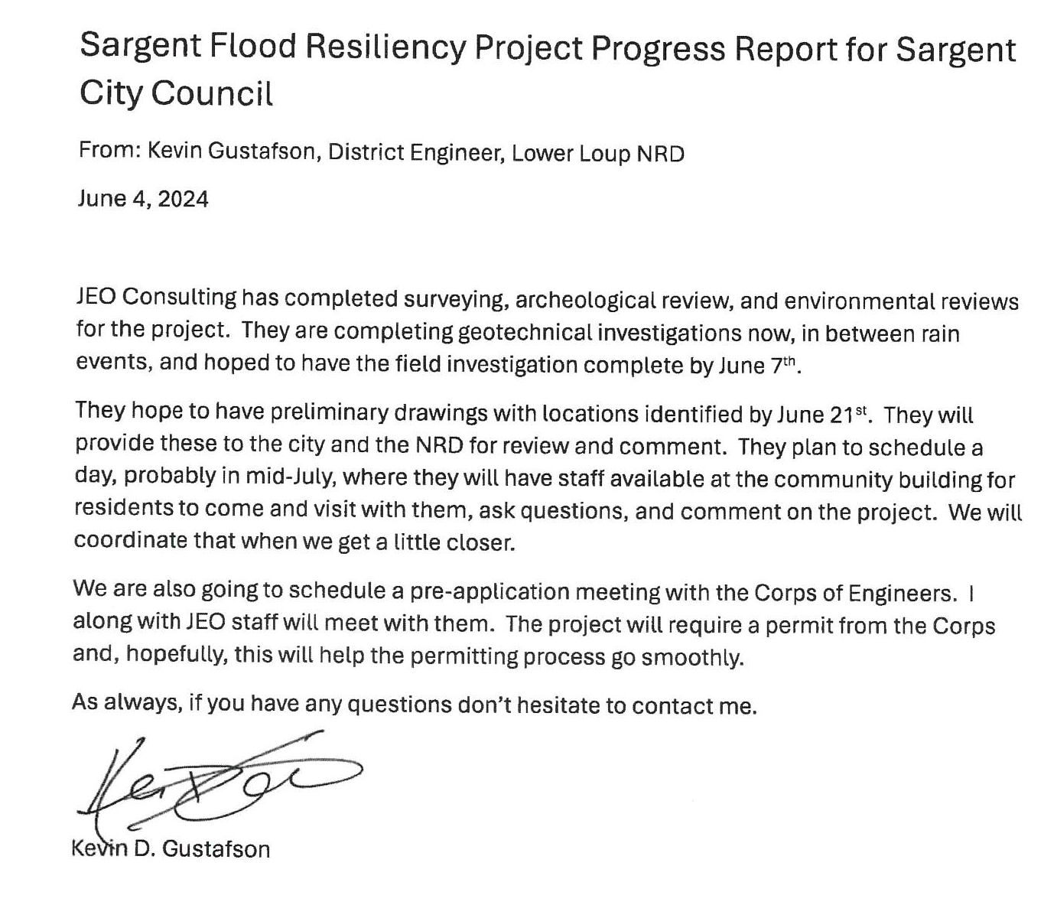
Supervisor Reports were given

The Mayor announced that the Council was going into executive Session for the protection of the public interest to discuss strategy with respect to pending or threatened litigation evidenced by a claim or threat of litigation, it being clearly necessary for the protection of the public interest.

Council Schneider moved to go into executive session for the protection of the public interest to discuss strategy with respect to pending or threatened litigation evidenced by a claim or threat of litigation, it being clearly necessary for the protection of the public interest at 7:21 pm. Council Member Clayton seconded. Voting yea: Schneider, Hightower, and Clayton,. Voting nay: None. Motion carried

The City Council came out of executive session at 7:42 pm

Motion made by Council Member Schneider and seconded by Council Member Clayton to adjourn the meeting. Voting yea:, Schneider, Hightower, Clatyon and Sheets.. Voting nay: None. Motion carried. Meeting adjourned at 7:43 P.M.

________________________________
Mayor

__________________________________

City Clerk

Community Development
 | Check # | Date | Vendor | Amount
 | 220 | 5/14/2024 | The Ritz | 6,000.00
 |  |  | Loan
 | 221 | 5/14/2024 | The Ritz | 600.00
 |  |  | Grant
 | 222 | 5/14/2024 | Nolan Osborn | 5,000.00
 |  |  | STOP scholarship
 | 223 | 5/20/2024 | Sargent Fair Board | 2,000.00
 |  |  | Fair Events
Municipal
 | 12524 | 6/11/2024 | Appeara | 241.95
 |  |  | Supplies
 | 12525 | 6/11/2024 | CDS | 500.00
 |  |  | Disaster Housing - Lead Paint
 | 12526 | 6/11/2024 | CDS | 1,495.00
 |  |  | Disaster Housing - Admin
 | 12527 | 6/11/2024 | Bates Construction | 7,340.20
 |  |  | Disaster Housing - Maintenance
 | 12528 | 6/11/2024 | Marten Heating & Cooling | 7,264.34
 |  |  | Disaster Housing Maintenance
 | 12529 | 6/11/2024 | Deterdings | 304.85
 |  |  | Supplies
 | 12530 | 6/11/2024 | Eakes Office Plus | 213.54
 |  |  | Office Supplies
 | 12531 | 6/11/2024 | Nebraska Central Telephone Company | 315.16
 |  |  | Phone & Internet
 | 12532 | 6/11/2024 | Paige Brewster | 1,494.60
 |  |  | Training
 | 12533 | 6/11/2024 | Sagrario Castellon | 85.00
 |  |  | cleaning
 | 12534 | 6/11/2024 | Sargent Corner Market | 481.13
 |  |  | Supplies
 | 12535 | 6/11/2024 | Trotter Grain & Fertilizer-Sargent | 408.00
 |  |  | Supplies
 | 12536 | 6/11/2024 | Trotter's Whoa & Go | 822.30
 |  |  | Fuel
 | 12537 | 6/11/2024 | Burwell Tribune | 43.50
 |  |  | Ad for lifeguards
 | 12538 | 6/11/2024 | Custer County Highway Dept | 1,000.00
 |  |  | Patching Material
 | 12539 | 6/11/2024 | Grint Farm Supply | 488.68
 |  |  | Supplies
 | 12540 | 6/11/2024 | Verizon | 40.01
 |  |  | IT Equipment
 | 12558 | 6/28/2024 | Spelts Lumber | 128.87
 |  |  | Supplies
 | 12560 | 6/28/2024 | Black Hills Energy | 1386.4
 |  |  | Utilities
 |  |  | June Municipal Payroll | 27,991.15
Utility
 | 14488 | 5/14/2024 | Border States Industries, Inc | 4,100.82
 |  |  | Supplies
 | 14490 | 5/14/2024 | Dept of Energy | 4,151.31
 |  |  | Purchase Energy
 | 14491 | 5/14/2024 | Grint Farm Supply | 482.65
 |  |  | light - Supplies
 | 14492 | 5/14/2024 | Hometown Leasing | 71.52
 |  |  | Water - Copier Lease
 | 14493 | 5/14/2024 | J & J Sanitation | 8,943.19
 |  |  | Customer Fees - $7,323.19
 |  |  | City Roll Off - $1,620.00
 | 14494 | 5/14/2024 | Mick Kozeal | 79.06
 |  |  | Mileage to Elba
 | 14495 | 5/14/2024 | Loup Central Landfill Assoc. | 497.00
 |  |  | Assessment
 | 14496 | 5/14/2024 | MEAN | 1,000.00
 |  |  | light- SLEIS Cert of Compliance
 | 14497 | 5/14/2024 | NE Public Health Env Laboratory | 48.00
 |  |  | Water - Lab Test
 | 14498 | 5/14/2024 | NE Safety & Fire Equipment Inc | 149.00
 |  |  | Inspection of light plant
 | 14499 | 5/14/2024 | NMPP | 2,040.00
 |  |  | EIA 860,861,923 Reports
 | 14500 | 5/14/2024 | One Call Concepts, Inc | 18.40
 |  |  | Diggers
 | 14501 | 5/14/2024 | Postmaster | 544.00
 |  |  | Stamps
 | 14502 | 5/14/2024 | Sargent Corner Market | 40.21
 |  |  | Supplies
 | 14503 | 5/14/2024 | Sargent Tire | 17.22
 |  |  | Chey Pickup light
 | 14504 | 5/14/2024 | Sonnia Grint | 80.00
 |  |  | Reece supplies
 | 14505 | 5/14/2024 | The Parts Bin | 134.93
 |  |  | Supplies
 | 14506 | 5/14/2024 | Trotter Grain & Fertilizer-Sargent | 448.00
 |  |  | ground cover
 | 14507 | 5/14/2024 | Trotter's Whoa & Go | 351.55
 |  |  | Fuel
 | 14515 | 5/31/2024 | Black Hills Energy | 365.79
 |  |  | Utilities
 | 14516 | 5/31/2024 | Custer Public Power District | 22,224.31
 |  |  | Purchase Power
 | 14517 | 6/11/2024 | Appeara | 178.24
 |  |  | Supplies
 | 14518 | 6/11/2024 | Border States Industries, Inc | 792.92
 |  |  | Supplies
 | 14519 | 6/11/2024 | Dept of Energy | 3,969.56
 |  |  | Purchase Energy
 | 14520 | 6/11/2024 | Eakes Office Plus | 213.55
 |  |  | Office Supplies
 | 14521 | 6/11/2024 | Forrest Gabrielson | 14.84
 |  |  | Deposit Refund
 | 14522 | 6/11/2024 | Hometown Leasing | 66.52
 |  |  | Sewer - Copier Leases
 | 14523 | 6/11/2024 | Iowa Pump Works | 3,196.48
 |  |  | Repairing pump
 | 14524 | 6/11/2024 | Mick Kozeal | 79.06
 |  |  | Mileage to Landfill meeting
 | 14525 | 6/11/2024 | Kylie Hansen | 100.00
 |  |  | Deposit Refund
 | 14526 | 6/11/2024 | MARC | 2,340.00
 |  |  | Degreaser
 | 14527 | 6/11/2024 | Sargent Corner Market | 122.50
 |  |  | Supplies
 | 14528 | 6/11/2024 | Trotter's Whoa & Go | 555.42
 |  |  | Fuel
 | 14529 | 6/11/2024 | Automated Dairy specialists, LLC | 933.60
 |  |  | Chlorine
 | 14530 | 6/11/2024 | Grint Farm Supply | 363.45
 |  |  | Supplies
 | 14531 | 6/11/2024 | One Call Concepts, Inc | 2.78
 |  |  | Diggers
 | 14532 | 6/11/2024 | Sargent Municipal Utilities | 185.16
 |  |  | Deposit Refund F Gabrielson- 280
 | 14537 | 6/20/2024 | J & J Sanitation | 9,483.19
 |  |  | Customer Fees -7,328.19
 |  |  | City Roll Off -2,160.00
 | 14539 | 6/28/2024 | Black Hills Energy | 184.84
 |  |  | Utilities
 | 14550 | 6/28/2024 | Custer Public Power District | 21,046.84
 |  |  | Utilities
 |  |  | June Utility Payroll | 21907.23

